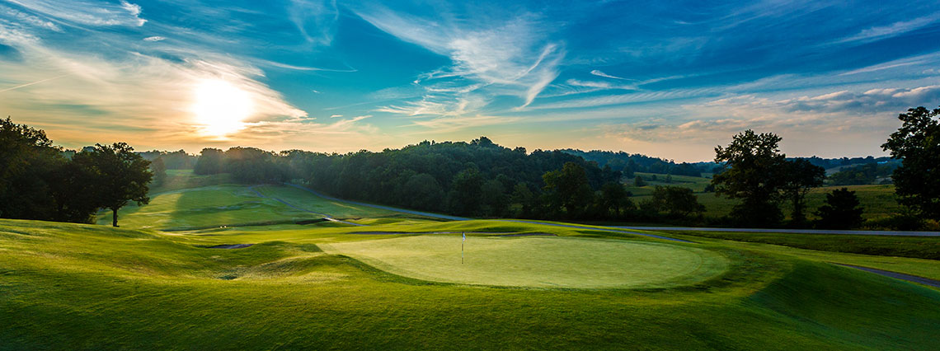
2020 CHARITY GOLF DAY
Friday 01 May 2020 I Kew Golf Club
120 Belford Road, East Kew
www.rcm.org.au/golf-day

Do you care about prostate cancer and fighting this disease?

Help us hit prostate cancer off the green and beat the most common cancer in Australian men.
Enter a team or as an individual in the 2020 Charity Golf Day.

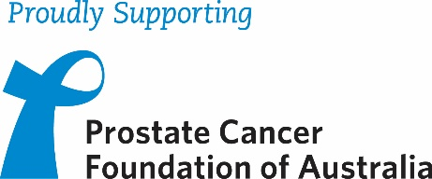

Proceeds from this event will be donated to Prostate Cancer Foundation of Australia (PCFA) to fund world leading, innovative research and to support men and their families affected by prostate cancer with evidence-based information and resources, support groups and Prostate Cancer Specialist Nurses.

COST INFORMATION:
$ 150 per player
Cost includes golf, light breakfast with coffee / tea on arrival and a two – course lunch following the game.

EVENT INFORMATION:
Event: 4 person Ambrose
7:00am: Registration
7:15am: Breakfast
7:45am: Briefing
8:00am: Shotgun start
12.30pm: Lunch
2.00pm: Presentation/Prizes
3.00pm: Finish
REGISTRATION FORM
Please complete the details below and return via e-mail to souladrummond@gmail.com

Name: ……………………………………………………………………………………………………………………………………………………………………………………………………………………………….
Organisation: ……………………………………………………………………………………………………………………………………………………………………………………………………………..
Address: …………………………………………………………………………………………………………………………………………………………………………………………………………………………..
Mobile: ……………………………………………………………………………………… Email: …………………………………………………………………………………………………………………
NAME OF PLAYERS | EMAIL | MOBILE | GA  H’CAP | GOLFLINK NO.
1.
2.
3.
4.
Please Note: Players without an official GA Handicap will be given a maximum handicap of 27 (Men) and 36 (Ladies)

COST: $150 per player TOTAL: $.......................

METHOD OF PAYMENT (Please tick):
Cheque payable to Rotary Club of Manningham  Form and cheque can be mailed to Soula Ganiatsas,  c/- PO Box 180, Doncaster East Vic 3109 | EFT  BSB: 633 000 Account No: 149 907 875  Comment: RCMGolf and your surname
CANCELLATIONS: Fees are non-refundable or transferable. Substitutions can be made in writing addressed to Soula via email to souladrummond@gmail.com. RCM will only reimburse registration fees if the event is cancelled. RCM is not responsible for any costs incurred as a result. Non-Attendance: If a player fails to attend, fees will not be refunded or allocated to another event.

